
- Important Information
1.1 | This form is applicable to the following endowment products:
 | - Hollard Linked Endowment | - Hollard Fund Endowment
 | - Hollard Guaranteed Growth and Income Plan | - Hollard Safe and Secure Plan
 | - Hollard Wealth Accumulator | - Honey Endowment Plan
 | - Hollard Specialist Linked Endowment
 | - Limited Edition range of products (Please Note: A Security Cession is only permitted on The Limited Edition Growth Endowment portion of the Limited Edition Growth and Income Plan. The Limited Edition Income Plan may not be ceded as security.)
1.2 | Honey Investment Solutions values your privacy. To deliver our services, we and our service providers need to process the personal information you provide in this form. We will treat this information with caution, and we have put reasonable security measures in place to protect it.
1.3 | It is imperative that you familiarise yourself with the respective products information document (where available) and Policy Conditions. This is available from your Financial Services Provider, our Client Service Centre on 0860 202 202 or on our website at www.honeyinvestments.co.za.
1.4 | The cedent and cessionary (“the parties”) request The Administrator to note a security cession on this investment.
1.5 | This investment may not be ceded if it is already subject to a cession in favour of any other party.
1.6 | The parties agree that this form is not a deed of cession, but merely a request by the cedent and cessionary for The Administrator to note a cession as previously agreed between the parties.
1.7 | All documents must be sent by email to honey@hollardinvestments.co.za.
1.8 | Any instructions received on a public holiday or over a weekend will be processed on the next business day.
1.9 | Please note: The Administrator will only accept an application that has been signed by the investor or duly authorised person using either a physical “wet” signature or an electronic signature (that has an associated signing audit trail).

- Document Checklist
☐ | Completed security cession notice form.
☐ | Customer Due Diligence (CDD)/FICA documents for the Cessionary as per the CDD requirements list available on our website www.honeyinvestments.co.za


- Policyholder/Cedent Details
3.1 | Policyholder Name:
3.2 | Policy Number:
3.3 | Identity/Reg Number:
3.4 | Contact Number:
- Effective Date and Value of Security Cession
Please indicate the percentage of the policy to be ceded to the cessionary: | % | OR | R
- Cedent Communication regarding Cession
5.1 | Notification of this cession will be forwarded to your Financial Services Provider.
5.2 | You will be notified when The Administrator has recorded the cession by way of a letter. Please indicate your preferred communication method:
a. | ☐ Email:
b. | ☐ Post:
b. | Attention:
b. | Post Office: |  | Number: |  | Code:
b. | ☐ P.O Box ☐ Private Bag ☐ Other PO Special Service
- Cessionary Details
6.1 | Cessionary Name: |  |  |  |  | Reg No.:
 | Contact Details:
 | Tel: |  |  | Mobile:
 | Email:
6.2 | Registered Address:
 | Complex Name: |  |  |  |  |  | Unit No.:
 | Street/Farm Name: |  |  |  |  |  | Street No.:
 | Suburb/District:
 | City/Town: |  |  |  |  |  | Code:
6.3 | Postal Address:
 | Postal address the same as registered address: ☐ Yes ☐ No – if No, please complete details below.
 | Post Office:

 | Number: |  |  |  |  |  |  |  |  | Code:
 | ☐ P.O Box ☐ Private Bag ☐ Other PO Special Service
 | Tax Number: |  |  |  | Tax Office:
6.4 | Communication to Cessionary regarding Cession:
 | You will be notified when The Administrator has recorded the cession by way of a letter. Please indicate your preferred communication method.
a. | ☐ Email:
b. | ☐ Post:
b. | Attention:
b. | Post Office: |  |  | Number |  |  |  |  |  |  | Code:
b. | ☐ P.O Box ☐ Private Bag ☐ Other PO Special Service
- Cedent Declaration
7.1 | I/We, as the current owner/s (cedent) of the policy as listed in herein, hereby cede all its rights, title, and interest in this policy in the proportion specified, together with all the benefits and advantages to be derived therefrom as security, to the cessionary named herein.
7.2 | Ownership of the policy does not change and will remain with the cedent, subject to the security interest of the cessionary.
7.3 | Should I be married in community of property in terms of the Matrimonial Property Act, I declare that, prior to the signature date of this instruction, I have obtained the consent of my spouse for this instruction.
7.4 | I declare that my estate is and has not been sequestrated.
7.5 | I/We further confirm that no previous cessions are currently in force on the policy detailed herein and that I/we am permitted as such to request this cession be made now.
7.6 | I/We confirm my/our understanding of the implications of the cession of the policy to the specified cessionary.
7.7 | I/We acknowledge and agree that all electronic representations of all documents, including this form, and any other instructions hereafter, including mandates, consents, commitments, and the like, which purport to emanate from me/us, shall be deemed to have been given by me/us in the form received by The Administrator. I/We hereby waive any rights I/we may have or may obtain against The Administrator arising directly or indirectly from any losses or damages that I/we may suffer because The Administrator acted on any purported electronic representations, and I/we indemnify The Administrator against any claims, demands or actions suffered by them because they acted on an electronic representation.
7.8 | I/We confirm that I/we have signed this declaration of my/our own free will and I/we regard it as binding.
7.9 | I/We confirm that I/we have not been influenced or coerced in any manner to cede this policy as detailed herein.

 | 7.10 | I/We confirm that all the details completed herein are true and accurate at the time of completion, and agree to notify The Administrator in writing should any details be discovered to be false or incorrect, prior to the implementation of the cession in question;
 | 7.11 | Signature:
 | 7.11 | 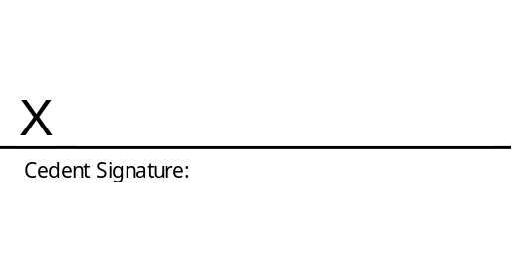
 | 7.11 | Official Capacity: |  | Official Capacity:
 | 7.11 | Name: |  | Name:
 | 7.11 | Date: |  | Date:
* If the cedent is under the age of 18, this signature must be that of the person acting on behalf of the cedent.
- Cessionary Declaration
8.1 | I/We, the authorised signatory, hereby confirm that I/we am duly authorised to sign on behalf of the cessionary named herein.
8.2 | I/We, as cessionary named herein, hereby accept that the policy as numbered herein, has been ceded to us for security purposes.
8.3 | We confirm that we have read and understood all relevant documentation pertaining to the policy and that we understand the benefits, restrictions and/or risks associated therewith.
8.4 | I/We agree with the details completed herein and, on implementation of this cession and thereafter, agree to notify The Administratorin writing should any of the said details change during the period of our cessionary status.
8.5 | Signature:
8.5 | 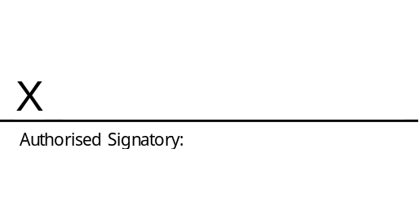
8.5 | Official Capacity: |  | Official Capacity:
8.5 | Name: |  | Name:
8.5 | Date: |  | Date:

