

- Important Information
1.1 | Honey Investment Solutions values your privacy. To deliver our services, we and our service providers need to process the personal information you provide in this form. We will treat this information with caution, and we have put reasonable security measures in place to protect it.
1.2 | The Product Provider/Administrator details are provided in each respective product information document.
1.3 | This form should not be used if you are appointing a person that is providing you with a financial service, e.g. advice or intermediary services, as defined in the Financial Advisory and Intermediary Services (FAIS) Act. If you wish to appoint a Financial Advisor on your investment account, please complete a change of Investment details form.
1.4 | It is imperative that you and the person acting on your behalf familiarise yourself with the respective products information document This is available from your Financial Services Provider, our Client Service Centre on 0860 202 202 or on our website at www.honeyinvestments.co.za.
1.5 | This instruction will only be processed once all investment requirements are met and all required documents are received.
1.6 | All documents must be sent by email to honey@hollardinvestments.co.za.
1.7 | Please note: The Administrator will only accept an instruction that has been signed by the investor/authorised person using either a physical “wet” signature or an electronic signature (that has an associated signing audit trail).

- Document Checklist
☐ | Completed person acting on behalf of investor form.
☐ | Proof of authority to act (where applicable).
☐ | Customer Due Diligence (CDD)/FICA documents for the person acting on your behalf as per the CDD/FICA requirements list available on our website www.honeyinvestments.co.za.
- Investor Details
3.1 | Investor Name:
3.2 | Contact Number:
3.3 | Identity/Reg Number:

3.4 | Apply the changes requested in this form to the following investment account numbers, as listed below:
3.4 | 1st Investment No.: |  | 2nd Investment No.:
3.4 | 3rd Investment No.: |  | 4th Investment No.:
3.4 | 5th Investment No.: |  | 6th Investment No.:
 | 7th Investment No.: |  | 8th Investment No.:
 | 9th Investment No.: |  | 10th Investment No.:
- Person Acting on Behalf of Investor
4.1 | Capacity:
4.1 | ☐ Parent |  |  |  |  |  |  | ☐ Court Appointed |  |  |  | ☐ Estate Late Executors
4.1 | ☐ Curatorship |  |  |  |  |  |  | ☐ Trustees |  |  |  | ☐ Power of Attorney
4.1 | ☐ Other
4.1 | Please note that certified proof of the capacity (where applicable) stated above will be required on the submission of this instruction, without which it will not be processed.
4.2 | Personal Details
4.2 | Title:
4.2 | Full Name & Surname:
4.2 | ID/Passport No: |  |  |  |  |  |  |  |  |  | Date of Birth:
4.3 | Address Details
4.3 | Residential/Registered Address:
4.3 | Complex Name: |  |  |  |  |  |  |  |  |  |  |  | Unit No:
4.3 | Street/Farm Name: |  |  |  |  |  |  |  |  |  |  |  | Street No:
4.3 | Suburb/District:
4.3 | City/Town: |  |  |  |  |  |  |  |  |  |  |  | Code:
4.4 | Postal Address:
4.4 | Postal address the same as residential address? ☐ Yes ☐ No If No, please complete details below:
4.4 | Address Type: ☐ PO Box ☐ Private Bag ☐ Postnet Suit ☐ Box/Bag/Suite No:
4.4 | Post Office Name: |  |  |  |  |  |  |  |  |  |  |  |  | Code:
4.5 | Contact Details:
4.5 | Tel: |  |  |  |  |  |  |  | Mobile:
4.5 | Email:

4.6 | Signature:
4.6 | 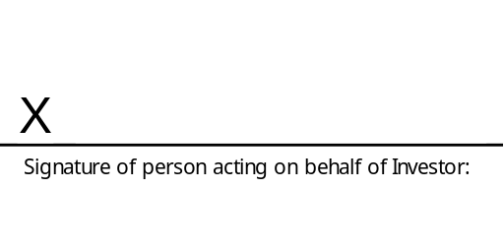
4.6 | Name:
 | Date:
- Investor Declaration
5.1 | I confirm that all information provided in this form is correct.
5.2 | The investor hereby appoints the ‘authorised person’ referred to in Section 4 as the investor’s lawful agent to act in accordance with the provisions contained in this form.
5.3 | I confirm that The Administrator may accept instructions from the authorised person appointed and authorised by me in terms of this form.
5.4 | I confirm that The Administrator may give the authorised person access to my investment accounts, including via the Honey Investments’ secure online portal.
5.5 | I understand that the authorised person is authorised by me to submit instructions on my investment accounts referred to in Section 3, by signing and/or submitting instructions on my behalf as well as request information on these investment accounts via telephone, or email from the Client Service Team.
5.6 | I have read and understood the information document applicable to the respective product.
5.7 | Signature
5.7 | 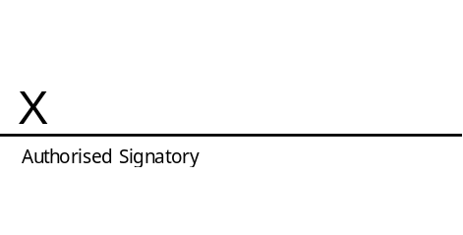
5.7 | Official Capacity: |  | Official Capacity:
5.7 | Name: |  | Name:
5.7 | Date: |  | Date:
* If the investor is under the age of 18, this signature must be that of the person acting on behalf of the Investor.

