

- Important Information
1.1 | Honey Investment Solutions values your privacy. To deliver our services, we and our service providers need to process the personal information you provide in this form. We will treat this information with caution, and we have put reasonable security measures in place to protect it
1.2 | The Product Provider/Administrator details are provided for in each respective product information document.
1.3 | If you would like to change any standing instructions such a recurring debit order or regular withdrawal; update beneficiary details; change a financial advisor fee etc., please complete the product specific change of investment details instruction form.
1.4 | It is imperative that you familiarise yourself with the respective product’s information document This is available from your Financial Services Provider, our Client Service Centre on 0860 202 202 or on our website at www.honeyinvestments.co.za.
1.5 | All documents must be sent by email to honey@hollardinvestments.co.za. This instruction will only be processed once all investment requirements are met and all required documents are received.
1.6 | Please note: The Administrator will only accept an instruction that has been signed by the investor or duly authorised person using either a physical “wet” signature or an electronic signature (that has an associated signing audit trail).

- Document Checklist
☐ | Change of residential address: Proof of address as per the Customer Due Diligence (CDD)/FICA requirements list available on our website www.honeyinvestments.co.za.
☐ | Change of Banking Details: Proof of banking details (bank statement, not older than 3 months).
☐ | Change of Name: South African bar-coded ID, passport (for foreign nationals), marriage certificate, or divorce decree.
☐ | Change of Tax Number: Confirmation of income tax number.
- Investor Details
3.1 | Investor Name:
3.2 | Identity Number:
3.3 | Investor Number:

3.4 | Contact Number:
- New Investor Details
Complete only the details you wish to change.
4.1 | Personal Details:
4.1 | Title:
4.1 | Full Name & Surname:
4.1 | ID/Passport No: |  |  |  |  |  |  | Date of Birth:
4.1 | Marital Status: ☐ Married ☐ Divorced ☐ Never married ☐ Other (please specify)
4.1 | Source of income (e.g. Salary, Pension, Savings):
4.1 | Source of Wealth (e.g. Property. Investments):
4.2 | Residential/Registered Address:
4.2 | Complex Name: |  |  |  |  |  |  |  |  |  |  | Unit No:
4.2 | Street/Farm Name: |  |  |  |  |  |  |  |  |  |  | Street No:
4.2 | Suburb/District:
4.2 | City/Town: |  |  |  |  |  |  |  |  |  |  | Code:
4.2 | Postal Address:
4.2 | Postal address the same as residential address? ☐ Yes ☐ No |  |  |  |  |  |  |  |  | If No, please complete details below?
4.2 | Address Type: ☐ PO Box ☐ Private Bag ☐ Postnet Suit ☐ Box/Bag/Suite No:
4.2 | Post Office Name: |  |  |  |  |  |  |  |  |  |  | Code:
4.3 | Contact Details:
4.3 | Tel: |  |  |  |  | Mobile:
4.3 | *Email:
4.3 | *Unless specifically instructed, The Administrator will send all correspondence via email. Refer to the section on Reporting and Correspondence.
4.4 | Income Tax Details:
4.4 | Country of Tax Residence |  |  |  |  |  |  | Income Tax Number:

- Change of Banking Details
Please complete this section if you would like to change your banking details:
5.1 | Please indicate to which standing instruction this change must apply:  ☐ Debit Orders ☐ Annuity Income Payments ☐ Regular Withdrawals
5.2 | Payments to 3rd party bank accounts are not allowed. Payment will only be made to a bank account in your name.
5.3 | For Debit Orders: If the bank account holder is a third-party, please provide the Customer Due Diligence (CDD)/FICA documents for the account holder as per the CDD/FICA requirements list available on our website www.honeyinvestments.co.za
5.4 | No payments will be made to offshore bank accounts, credit cards or market linked accounts.
5.5 | New Banking Details:
5.5 | Account Holder:
5.5 | Bank Name: |  |  |  | Branch Name:
5.5 | Account Number: |  |  |  | Code:
5.5 | Account Type: ☐ Savings ☐ Cheque/Current ☐ Transmission ☐ Other
5.5 | If this change of banking detail applies to an active debit order on my investment account, I confirm that I have reviewed the debit order mandate provided for in the product information document (where applicable) and hereby authorize The Administrator to draw debits against the bank account detailed above.
5.5 | 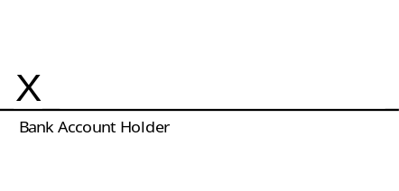
5.5 | Name: |  |  | Name:
 | Date: |  |  | Date:
- Reporting and Correspondence & Online Access
Reporting and Correspondence
6.1 | It is your responsibility to ensure that the details for reporting and correspondence held by The Administrator are current and accurate. The Administrator will not be held liable for communications of any nature not being received by you, or any circumstances that may arise as a result of such non-receipt. Unless specifically instructed, The Administrator will send all correspondence via email.

6.2 | Do you require all correspondence to be sent to your nominated FSP (Financial Services Provider) in addition to being sent to you? ☐ Yes
Manage your Investment Online
Honey Investments Online enables you to view and manage your investments on a secure platform . We need an email address and mobile number to set up your online account.
6.3 | Please tick this box if you want online access: | ☐
6.4 | Email Address (mandatory):
6.5 | Mobile number (mandatory):
- Investor Declaration
7.1 | I confirm that all information provided in this form is correct.
7.2 | I understand that, depending on the details provided in this form, The Administrator may request additional information from me.
7.3 | I have read and understood the information document applicable to the respective product.
7.4 | Signature:
7.4 | 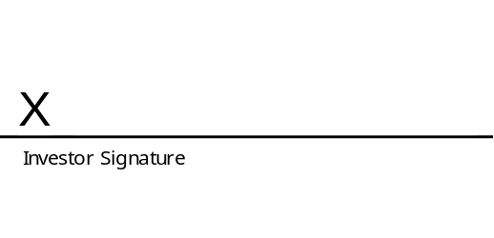
7.4 | Official Capacity: |  | Name:
 | Date:

